## 10.Write a PROLOG program to implement memb(X, L) : TO Check whether X is a member of L or not.

**CODE**

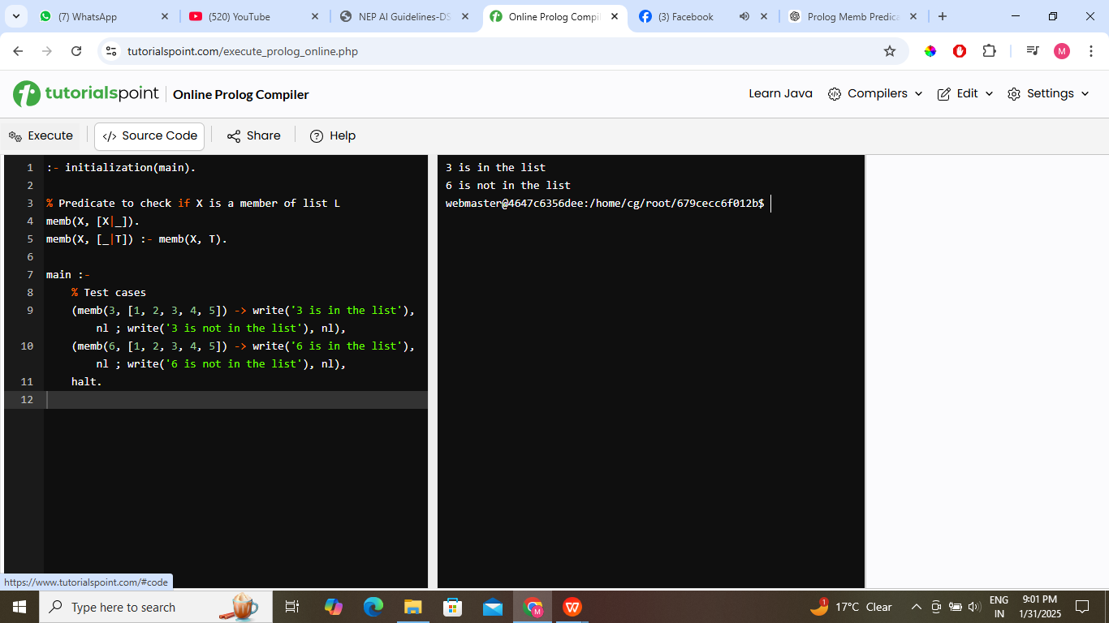

## 11.Write a PROLOG program to implement sumList(L, S) so that S is the Sum of given List L:

**CODE**

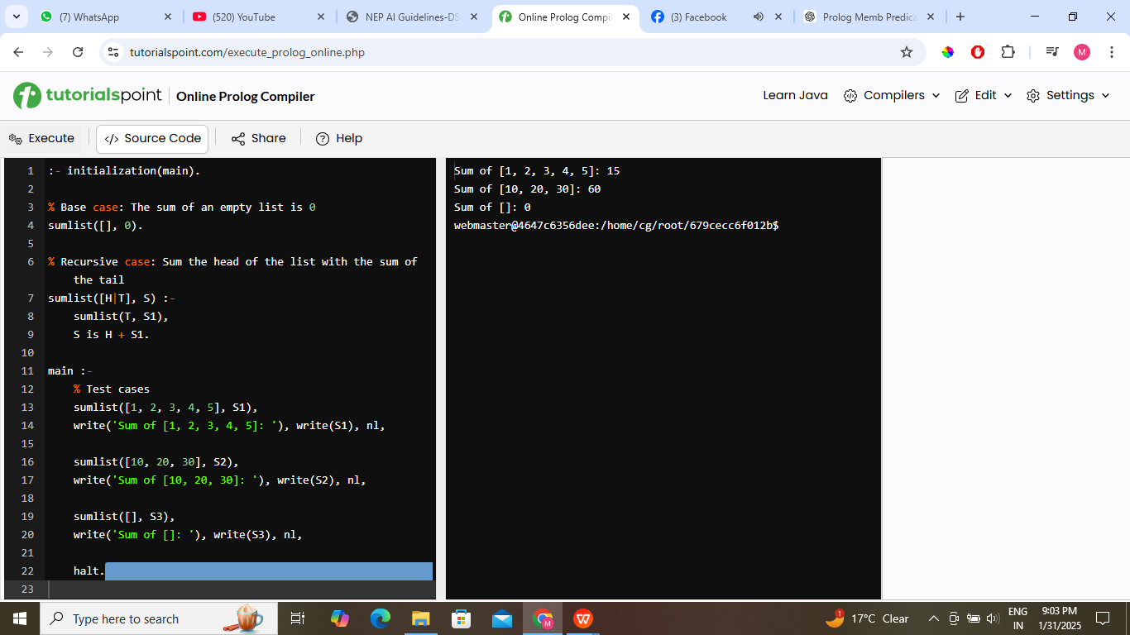

## 12.Write a PROLOG program to implement two predicates evenlenght (list) and oddlenght(list) so that they if their argument is a list of even or odd length respectively.

**CODE**

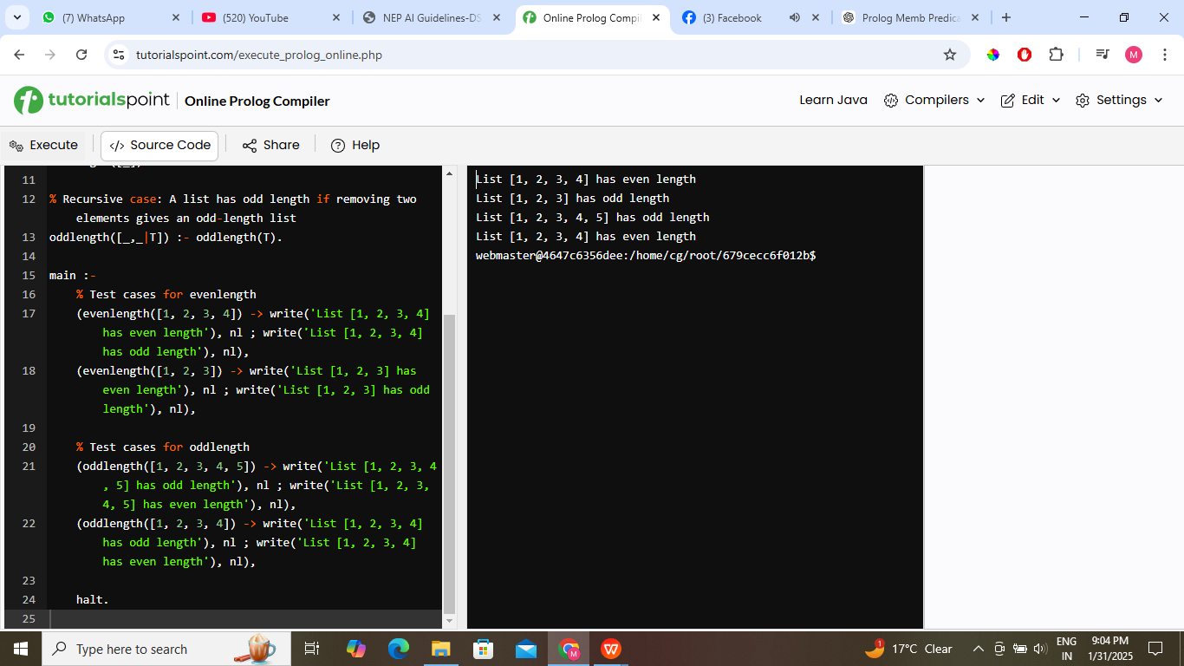

## 13.Write a PROLOG program to implement maxlist(L, M) so that M is the maximum number in the list .

**CODE**

